Interface :HardWare

Methods :hardwareResources()

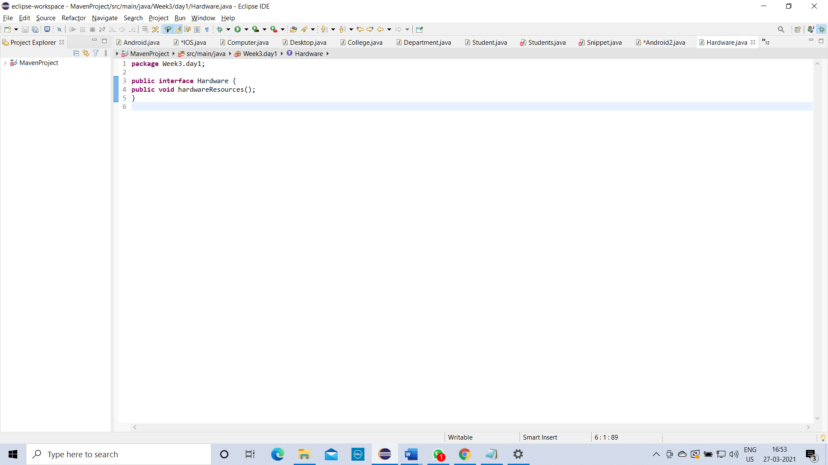

Interface :Software

Methods :softwareResources()

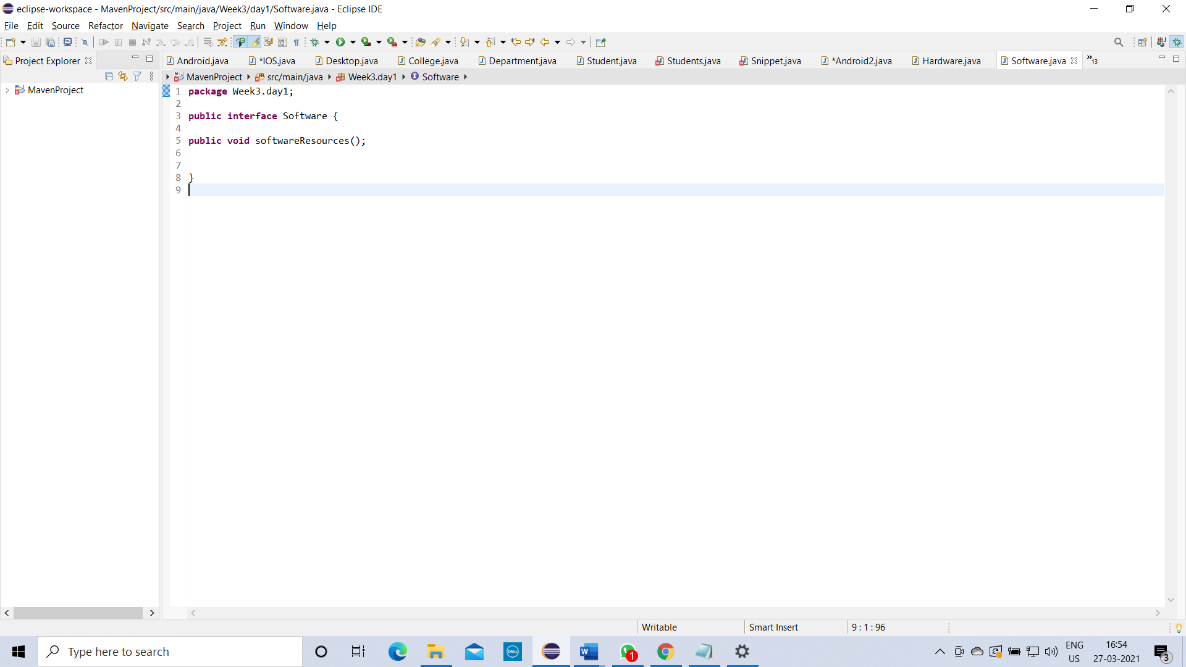

Class :Desktop

Methods :desktopModel()

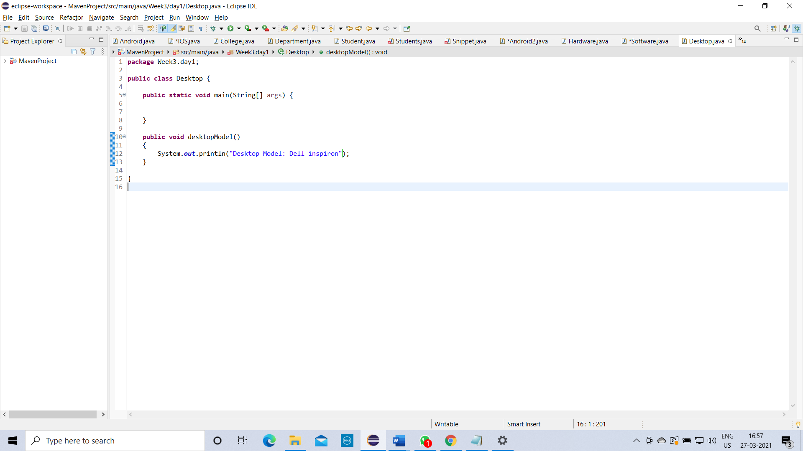

**Description:**

**create 2 Interface and archieve multiple inheritance.**

Call hardware interface in to software interface by using extends

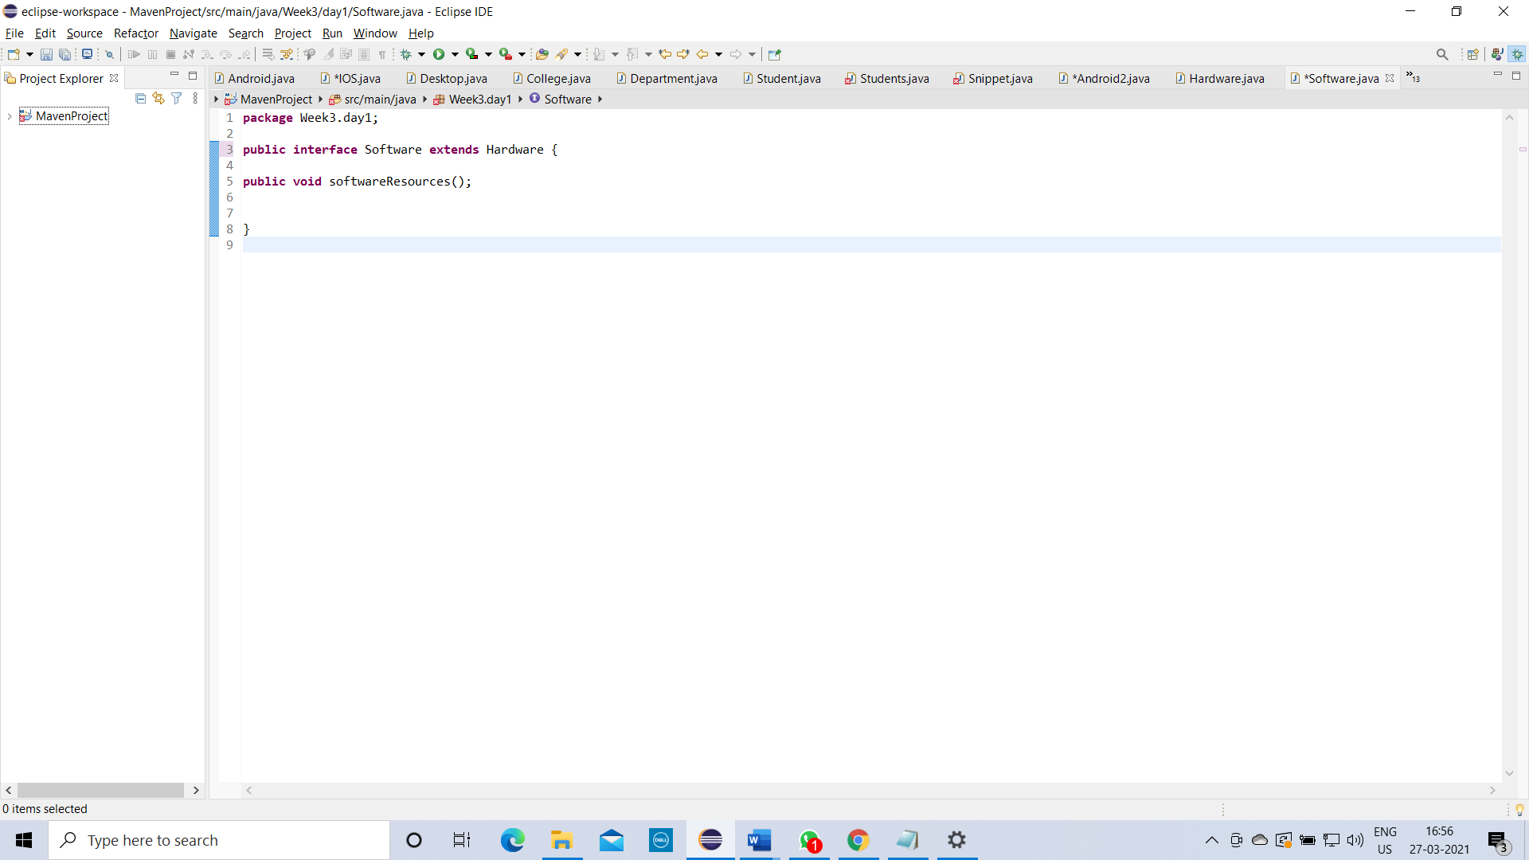

Call software interface into Desktop class by using implements keyword

